**Week 2 Introduction to Technological Innovation**

1. **Definition of Innovation**

* Innovation involves idea + application of that idea (“ideas successfully applied”)
* Innovation requires combining a creative idea with resources and expertise that make it possible to embody the creative idea in a useful form

1. **The Importance of Innovation**
2. Importance of innovation to a country:

(Innovation is a driver of productivity, growth, improvement in living conditions)

- Is often the most important competitive driver in many industries

- Leads to improvements in productivity

- Is strongly linked with improvements in Gross Domestic Product (GDP)

- Is typically linked to improvements in standard of living including: Job creation, Improved enjoyment of life, Health improvements, Education improvements, Addressing national or global issues including by: Decreasing pollution, Improving disaster response

1. Importance of innovation to companies

(Innovative companies usually have greater productivity, revenue, growth and

social contributions)

Compared to Australian businesses that don’t innovate, innovative Australian businesses are also:

- more likely to report increased profitability;

- more likely to export and to increase the number of export markets targeted;

- more likely to increase the range of goods or services offered;

- more likely to increase employment;

- more likely to increase training for employees;

- more likely to increase social contributions

1. Innovation as “Creative Destruction”

* Definition: the opening up of new markets… and the organizational development ... illustrate the same process of industrial mutation, that incessantly revolutionizes the economic structure from within, incessantly destroying the old one, incessantly creating a new one

waves that restructure entire industries and markets in favor of those who grasp and adapt to technological discontinuities faster

* Entrepreneurs within new firms drive innovation: All companies react adaptively to change; Creative responses to change come via innovative acts by entrepreneurs
* Different forms of innovations: New products; New organizations (e.g. mergers); New markets
* Innovating firms emerge after technological breakthrough

1. **The importance of IT Innovation**
2. IT is a “General Purpose Technology”

GPTs differ from other technologies and:

-Are pervasive – spreading to most sectors

-Continually improve in usefulness and lower in cost

-IT as enabler of innovation in other fields (e.g. bio-informatics: SARS, With software, we can determine the source of the virus; the geographic or time origin of the virus; genetic, geographic and evolutionary history of the virus)

1. IT innovation as creative destruction

“Why software is eating the world” (2011)

* More major businesses/industries are being run on software and delivered as online services
* Technology required to transform industries through software finally works and can be delivered globally
* Front end: billions of people with smartphones
* Back end: software tools to launch global software-powered start-ups with no need for infrastructure

(eg. Amazon book seller)

1. **\* Sources of innovation**

Transforming creativity into innovation

This transformation happens in:

A. Established companies

-Technology or product development in R&D departments

-Process innovation throughout the company

-Business model innovation in business units

B. Startup companies

C. Universities

D. Research institutions

E. Individuals

1. **Types of Innovation**

Types of innovation according to different dimensions:

1) What **type** of thing is being innovated?

Product/service vs process vs business model innovation

* **Product innovation** is embodied in the outputs of organizations – could be product or service
* **Process Innovation** involves the discovery and implementation of a new or improved production or delivery method; The process could be related to production/engineering or related to business processes

**Relation between product innovation and process innovation**:

-Product innovations can enable process innovations;

-Process innovations can enable product innovations;

-What is a product innovation for one organization might be a process innovation for another

(eg. a package delivery service creates a new distribution service (product innovation) that enables its customers to distribute their goods more widely or more easily (process innovation)

* **Business Model Innovation** New and radically new business models: Many web-based innovations are built around business model innovations.(eg,uber)

2) How **different** is it from what’s already available?

- **Radical innovation**:

-The radicalness of an innovation is the degree to which it is new and different from existing products and processes;

-The radicalness of an innovation is relative;

-it may change over time or with respect to different observers (E.g. 3D printer)

- **Incremental innovations**

may involve only a minor change from (or adjustment to) existing practices. (E.g. a new feature in Microsoft Word)

3) What impact will it have on the consumer?

- Life-changing vs incidental innovation

4) What impact will it have on the market?(later)

- Disruptive vs sustaining innovation

5) What scope of the product/service/process does it affect?

- An **architectural innovation** entails changing the overall design of the system or the way components interact. (E.g. cloud computing)

- A **component innovation** involves changes to one or more components of a product system without significantly affecting the overall design.

(E.g., changing the algorithm for face detection in a camera for higher performance)

Most architectural innovations also require changes in the underlying components.

6) What impact will the innovation have on the producers?

- **Competence-enhancing innovations** build on the firm’s existing knowledge base

(E.g., Intel’s Pentium 4 built on the technology for Pentium III.)

- **Competence-destroying innovations** render a firm’s existing competencies obsolete

(E.g. Kodak invented the first digital camera)

Both innovations Depends on the perspective of a particular firm:

(E.g. digital cameras were not competence-destroying for Canon as they already had microelectronics expertise.)

**Week 3 Industry dynamics of technological innovation: Technology cycles and design dominance**

1. **Diffusion of innovations through society**
2. Definition: Diffusion is the process in which (1) **an innovation** is

(2) **communicated** through certain **channels** (3) **over** **time** among

(4)**the members** of (5) a **social system**.”

1. Stages in the Innovation-Development Process:

* Recognizing a problem or need
* Basic and applied research: Scientific investigation
* Development: Putting a new idea into a form to meet the needs of users
* Commercialization: Production, manufacture, packaging, marketing, distribution
* Diffusion and adoption: Spreading innovation through members of a social system
* Consequences

1. 5 types of adopters

* Innovators: Take risks; Access to new tech
* Early Adopters: Opinion leaders
* Early Majority: Wait before adopting
* Late Majority: Initially skeptical
* Laggards: Aversion to change

1. “The Chasm”-between early adopters and the early majority
2. Technology adoption S-curve

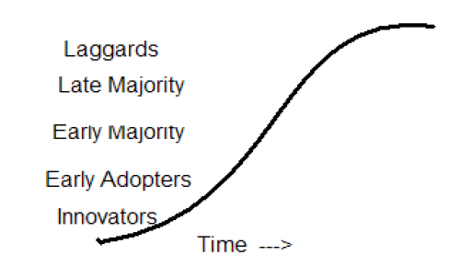

1. The process of innovation adoption: Adoption by individuals/organizations

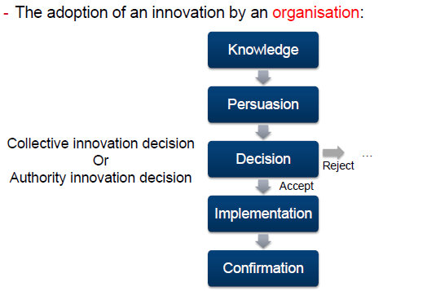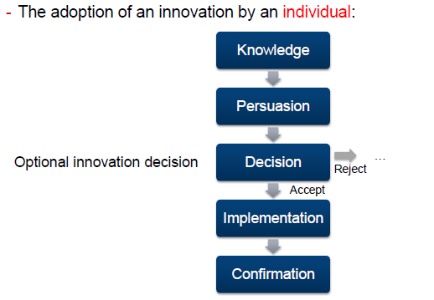

1. Factors influencing speed of adoption

* **Relative advantage** – extent it is viewed as better than the idea it supercedes.
* **Compatibility** – extent it is perceived as consistent with the existing values, past experiences, and needs of potential adopters.
* **Simplicity** (vs Complexity) – extent it is perceived as simple to understand and use.
* **Trial-ability** – degree it may be experimented with on a limited basis (low cost, “free trial offer”).
* **Observe-ability** – extent to which results of an innovation are visible to others, who imitate.

Rate also affected by:

* Extent of Change Agents’ Promotion Efforts (eg marketing)

1. **Improvements in technological performance**

* Another use of the “S-curve”: the “technology performance S-curve”
* Used to show and predict the performance improvement of a technology
* Shows that the performance of a technology starts slowly, then improves approximately exponentially, then slows and eventually saturates

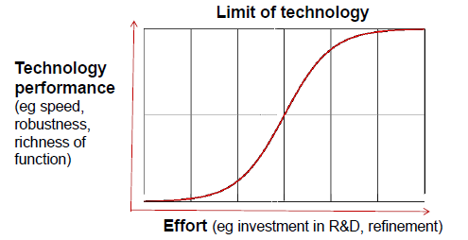

1. **Maturity and adoption of new technologies:**
2. Uses:

- Strategic planning of technology development

- Companies considering adoption of a technology

- Investors investing in technology

B. Some criticisms

-Development of each Gartner Hype-Cycle is not done scientifically – it is the opinions of market analysts based on market information at a point in time

-Technologies may appear already on the slope of enlightenment or disappear

-It only works for technologies that follow this model (eg it doesn’t deal well with technologies that never succeed or are quickly superseded)

-As it is widely-used, it is partly self-fulfilling (i.e. people may not adopt technologies as they don’t appear mature in the hype-cycle)

C. Summary: Useful but use with care



1. **The emergence of new product categories**
2. Definition: Product category

* A product category is all the products offering the same general functionality.
* A socially constructed partition of products that are perceived to be similar and in which firms choose to position their products

1. Factors that lead to a “dominant category”:

* Technological factors
* Firms attempts to claim advantageous market positions
* Stakeholders (eg customers, producers, critics, and regulators) making sense of emerging category
* Eg. SmartPhones; Fitness tracker; smartwatch

1. **Design dominance**
2. The concept of Design Dominance

- “Dominant Design” is the design around which the industry settles.

1. The process by which Design Dominance happens

1. When a new product is first introduced, it is usually “made-to-order”

2. If the product attracts significant market share (through whatever path – technological superiority, good marketing etc), it forces imitation by competition

3. Competitive products are released

4. There is pressure to reduce costs in components leading to commoditization of components (for mass production)

5. This requires there to be a “dominant design” with components fitting within this design

6. The dominant design may be established by the first company to release a product, a later arrival or by a standards body

7. The dominant design becomes a base for the whole industry

8. This design may become a defacto standard or a de jure standard

1. The phases of Design Dominance

* The fluid phase:

- Uncertainty about the technology and its market

- Firms experiment with different product designs

* The specific phase (i.e. innovations are specific to the dominant design):

-There is a stable architecture (dominant design) for the technology

-Firms focus on incremental innovations to improve components

-Firms focus on process innovations to produce them efficiently and effectively

(Eg. Android, IOS)

1. Design Dominance and Technology Cycles

* A new technology may cause a “technological discontinuity” in the industry leading to a new cycle
* They showed that technological discontinuities were competence-enhancing or competence-destroying for particular companies

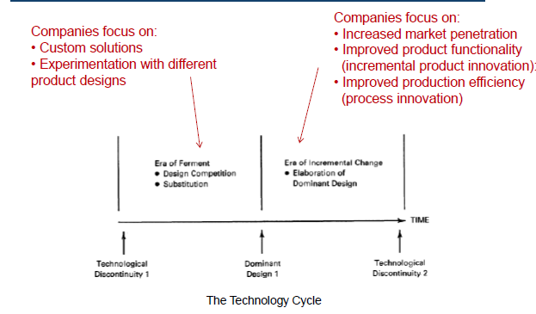

* In the cases studied by Anderson and Tushman, they found that:

- The dominant design was never in the same form as the original innovation

- The dominant design was not the leading edge of the technology

- The dominant design had the features that met the needs of the majority of the market (Example: The IBM PC were not the most advanced or the cheapest technology at the time it rose to dominance.)

- During the “era of incremental change”, firms typically focus on:

– Increased market penetration

• Segment the market offering different models at different price points

– Improved product/component functionality (incremental product innovation):

• New features and increased performance (faster, more scalable, etc)

– Improved production efficiency (process innovation):

• Lower production prices through simplification of components or process innovation

* This continues until the next technological discontinuity.
* Anderson and Tushman found:

-The era of incremental change accounted for most of technological process.

-That during the era of incremental change, firms:

-stopped investing in learning about alternative designs; and

-focused on developing competencies related to the dominant design.

* This helps explain why firms entrenched in a dominant design often don’t recognize or react to discontinuous technologies: (Eg Microsoft’s apparent slowness in identifying and acting on the importance of the Internet)

1. Standards for dominant designs

* Sometimes standards are used to encourage or maintain a dominant design in an industry
* Standards may be defined by:
* a formal standards organization (“de jure”); (Ms: Word Doc Formats, PC architecture)
* wide public acceptance or market forces (“de facto”) (TCP/IP USB)
* Standards may be for controlling:
* Quality (products/services have required characteristics);
* Compatibility (products/services can be used with other products/services)
* Compatibility standards can be:

+ Sponsored (a party or parties hold a proprietary interest in a particular technology and in the adoption of it by others); or

+ Non-sponsored

1. Why do dominant designs get selected in a market?

* Market forces: Increasing returns to adoption

For many technologies (especially in IT), the more a technology is adopted, the more valuable it becomes to the industry because of:

* **Learning effects:** The industry gains knowledge in all aspects of the technology

›When a design is dominant, there is greater use of the technology.

›Greater use leads to greater knowledge accumulation about that technology

›Greater knowledge enables a fast rate of improvement of the technology

›Company structures and culture are based around the technology

* **Network effects:**

- The benefit of using a technology increases with the number of users.

- For technologies with network effects, the benefit from using a technology increases with the number of other users

›Direct network effects: Increase in usage leads to direct increase in value (eg Email, Telephone)

›Indirect network effects: Increase in usage leads to increase in value of complementary goods leading to increase in value of the original technology (PC Architecture gained value from value of compatible software)

›Two-sided network effects: Increase in usage by one set of users increases value to another set (eg marketplaces (such as eBay, Airbnb), reader/writer software)

›Local network effects: Increase in use of local networks (within a larger network) leads to increase in value (Eg Instant Messaging, Facebook)

›The self-reinforcing cycle: A technology with a large installed base attracts developers of complementary products; A technology with a wide range of complementary products attracts users;

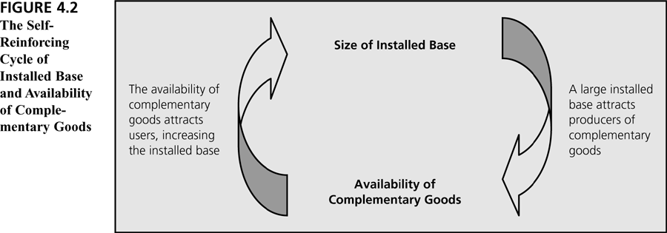

* **Government regulations**

Sometimes, the government sees the importance of a technology for a nation and regulates a specific dominant design (eg for TV, mobiles)

* There are often strong consumer or economy benefits of having a single dominant design
* Rather than wait for market forces, sometimes government organizations step in and impose a standard (Eg. GSM (General Standard for Mobile communications) for telecommunications)

1. Frameworks for modelling design dominance



Firm- and environment-level factors influencing the outcome of technology battles

Relationship between dominant category and dominant design

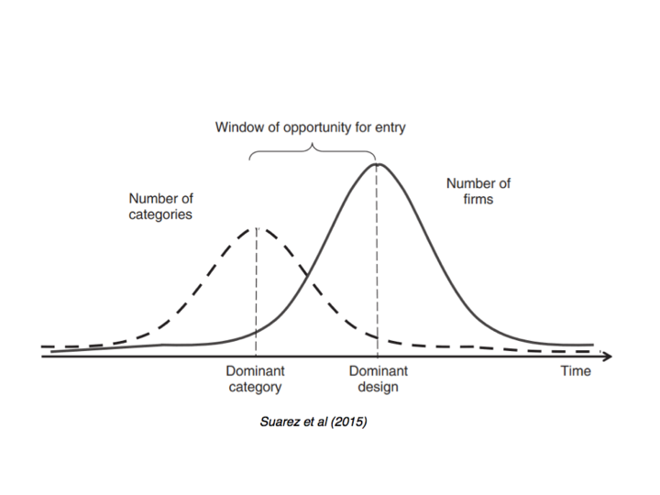

**Week 4 Disruptive innovation**

1. **Industry value chains and value networks**
2. *Porter’s “Value Chain”

* Typically describe how value is added within different business units of a company
* Products pass through stages and value is added at each stage
* More suited to manufacturing physical goods than IT
* Has been extended to show how value flows through an industry

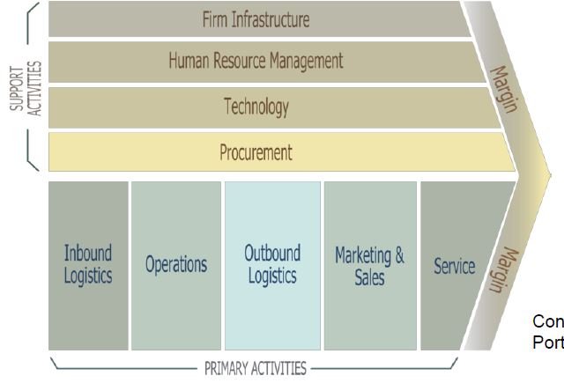

1. Industry value chains

* An industry value chain is how value is created and passed on between participants in an industry
* Diagrams can be used to show how value flows through the industry
* Value may be from licensing a technology, selling a product, providing a service, etc

1. *Supply Chains vs Value Chains

* Supply chain: “a channel of distribution beginning with the supplier of materials or components, extending through a manufacturing process to the distributor and retailer, and ultimately to the consumer”

1. Value Network

* Definition: the collection of upstream suppliers, downstream channels to market, and ancillary providers that support a common business model within an industry.

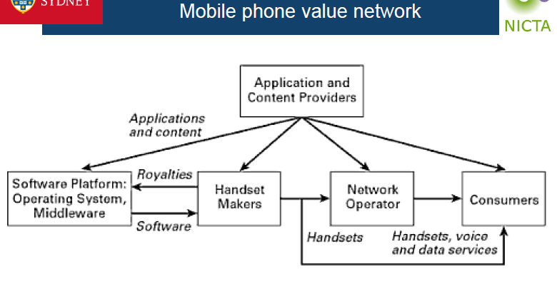

1. **Disruption Innovation**
2. “The Innovator’s Dilemma”

* Effective established companies study the needs of their customers
* The companies innovate to meet these customer needs
* The companies sell new products/versions to their customers
* The most important existing customers are the high-end ones who spend the most so the focus is on them
* The dilemma is that the more a company focuses on the needs of their high-end customers, the more likely it is that they will miss opportunities in emerging technologies

1. Disruptive Innovation

According to Christensen, innovations can be either disruptive or sustaining

* “Disruptive innovations” disrupt markets

(i.e. they create new markets or change the value network in an existing market)

* “Sustaining innovations” sustain markets

(i.e. there is no change to the value network in the market)

1. Types of disruptive innovation

Disruptive innovations create new markets or change the value systems within existing markets

- "low-end disruption” – there are customers who do not need the full functionality or performance of products already on the market so cheaper alternatives can take over. (eg. Telephony- Voice over IP -Skype; Traditional encyclopedias-Wikipedia)

- "new-market disruption" – there are customers who have needs that were not being addressed by existing products

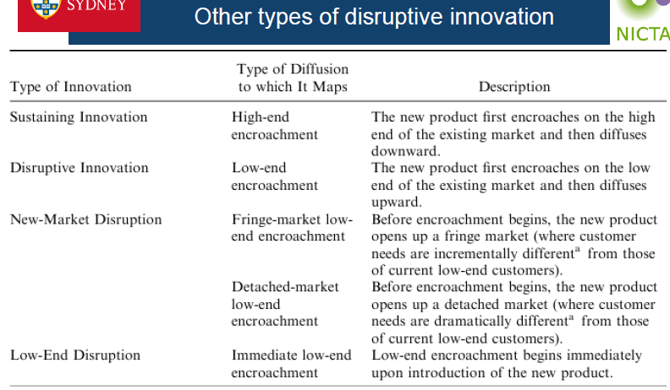

1. Analyzing a value network

* Analyzing value chains/networks is useful for:
* Understanding an industry (including relationships between companies)
* Understanding your company’s position within the market
* Deciding where your company wants to be within that market
* Looking for opportunities for disruptive innovations
* Looking for threats for disrupting the market you are in
* Understanding value chains/networks is useful:
* If you are an established company:

> In understanding emerging threats

> In designing a strategy to disrupt a market

* If you are a startup:

> In disrupting a market

* If you are in corporate IT:

>In understanding how products and solutions may change

1. Disrupting value networks

Disrupting value networks can be done by:

1. Analyzing the value network and attempting to change it:

-“**Disintermediation**” = “cutting out the middleman”: Common using the Internet (eg book flights from the airline directly)

-“**Reintermediation**” = adding in a new intermediary: Also common using the Internet (eg new types of travel agent – WebJet, Flightfox, etc)

b) **Ignoring** the current value network and having it change around you: Also common using the Internet

**Week5 Innovation systems and distributed innovation**

1. **Innovation systems**

Innovation system models: Parties involved, framework conditions, government policy;

* Companies are continually innovating to stay competitive
* Entrepreneurs are continually looking for opportunities to change the value network
* Companies are being created and being destroyed
* Industries are being created and being destroyed
* This doesn’t happen in isolation – there is a system (or eco-system) in which innovation happens.

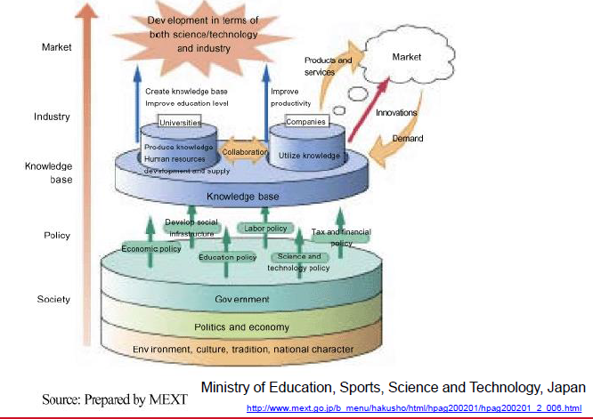

1. **Distributed Innovation**
2. *Evolution of innovation by companies: Traditional model

* Most R&D and other innovation done in-house
* Successful innovation required control
* Was used for most of the 20th century
* Some spreading of innovation through “spillovers”

1. *Evolution of innovation by companies: Some trends in the late 20th century

* Mobility of knowledge workers between companies
* Globalization
* Better information and communication technologies (eg email, web)
* Availability of venture capital funding
* Easier to create and build new technology companies
* So more opportunities for collaborative innovation

1. Distributed innovation Definition

A system in which innovation emanates not only from the manufacturer of a product but from many sources including users and rivals

1. Open Innovation
2. Definition:

›Many companies have changed from purely internal R&D activities to being open to outside ideas and innovations.

›Cooperation and collaboration with external parties to increase innovation and reduce time to market.

›“the use of purposive inflows and outflows of knowledge to accelerate internal innovation and expand the markets for external use of innovation”

1. Types of open innovation

* Outside-in process: “Enriching the company’s own knowledge base through the integration of suppliers, customers, and external knowledge sourcing”
* Inside-out process: “Earning profits by bringing ideas to market, selling IP, and multiplying technology by transferring ideas to the outside environment.”
* Coupled process: “co-creation with (mainly) complementary partners through alliances, cooperation, and joint ventures during which give and take are crucial for success.”

1. Some benefits of open innovation

* Larger base of ideas to draw from for innovation: “Not all of the smart people work for us” (Bill Joy from Sun Microsystems)
* Existing third-party technology can be used, reducing risk and cost of development from scratch
* Identification of new business opportunities with collaborators
* Share risks and pool resources with other companies
* Can be lower cost than large R&D departments

1. Risks of open innovation (compared to closed innovation)

* Lack of control: Will usually not have as tight control of external resources as internal ones
* Higher complexity of managing innovation Need to manage external relationship, intellectual property, confidentiality etc
* Higher coordination costs: May cost to coordinate external resources
* Possible loss of own capability over time: If are not using and building a capability but relying on others
* Possible loss of competitive advantage compared to others: If allow others to build skills in area important to your business, they can sell their expertise to your competitors (contracts can help address the risk)

Both traditional (“closed”) innovation and open innovation have benefits. Many companies do both and balance them.

1. Some approaches to open innovation
2. Product Platforms
3. Product Platforms Concepts:

* Concept became popular in the 90s – used for reusable components/design frameworks
* Foundation of components around which a company builds related products
* Also known as “product family engineering”
* Platforms make it possible for companies to:

>Have a rich line-up of different products with the same core functions:

At different price-points;

For different customer types

>To do so efficiently through re-use of a common platform (Eg. Canon Camera)

1. Product Platforms: Benefits

* For internal product platform: Reuse technology component in multiple products leading to:

> Faster development time so gets to market sooner

>☺ Lower effective cost (as spread over multiple products)

>☺ Innovative aspects of the platform can benefit a range of products

>☺ Application development on platform can focus on innovative value-add

* But also platform can be made available externally, leading to new businesses and new business models (eg Web API)

1. Some ways in which companies provide IT product platforms

* Make source code available:

Allows external innovators to modify the software for their own needs

Eg: Core Java platform

* Provide toolkit (software and documentation):

Allows external innovators to write software based on the toolkit

* Provide plug-in/add-on support in software:

Allows external innovators to customise software without access to source code

Eg: Firefox Add-ons

* Provide full product platform for external innovation

Allows external innovators to write rich and varied applications on the platform

Eg: Android and iPhone app architectures

* Provide live data/functionality via APIs

Allows external innovators to build new services using the data

Eg: Facebook API

1. Web APIs
2. Releasing data sets

* Many governments have opened up government data (“Open Data”)
* Some companies are doing it too
* They are encouraging users to develop websites and apps using the data:

> In some cases, static data (eg tables of static data)

> In some cases, live data feed (eg an RSS feed or data service)

E.g. Crime data, census data of NSW

1. Crowdsourcing
2. *Definition

* Crowd + Outsourcing
* Simply defined, Crowdsourcing represents the act of a company or institution taking a function once performed by employees and outsourcing it to an undefined (and generally large) network of people in the form of an open call. This can take the form of peer-production (when the job is performed collaboratively), but is also often undertaken by sole individuals. The crucial prerequisite is the use of the open call format and the wide network of potential laborers.
* Newer definition: Crowdsourcing is a type of participative online activity in which an individual, an institution, a non-profit organization, or company proposes to a group of individuals of varying knowledge, heterogeneity, and number, via a flexible open call, the voluntary undertaking of a task. The undertaking of the task, of variable complexity and modularity, and in which the crowd should participate bringing their work, money, knowledge and/or experience, always entails mutual benefit. The user will receive the satisfaction of a given type of need, be it economic, social recognition, self-esteem, or the development of individual skills, while the crowd- sourcer will obtain and utilize to their advantage what the user has brought to the venture, whose form will depend on the type of activity undertaken.
* (a) there is a clearly defined crowd;

(b) there exists a task with a clear goal;

(c) the recompense received by the crowd is clear;

(d) the crowdsourcer is clearly identified;

(e) the compensation to be received by the crowdsourcer is clearly defined;

(f) it is an online assigned process of participative type;

(g) it uses an open call of variable extent;

(h) it uses the internet.

1. Why do people engage with crowdsourcing?

Many varying reasons including (from Brabham reading):

›the desire to earn money;

›to develop one’s creative skills;

›to network with other creative professionals;

›to build a portfolio for future employment;

›to challenge oneself to solve a tough problem;

›to socialize and make friends;

›to pass the time when bored;

›to contribute to a large project of common interest;

›to share with others;

›to have fun.”

1. Types of Crowdsourcing

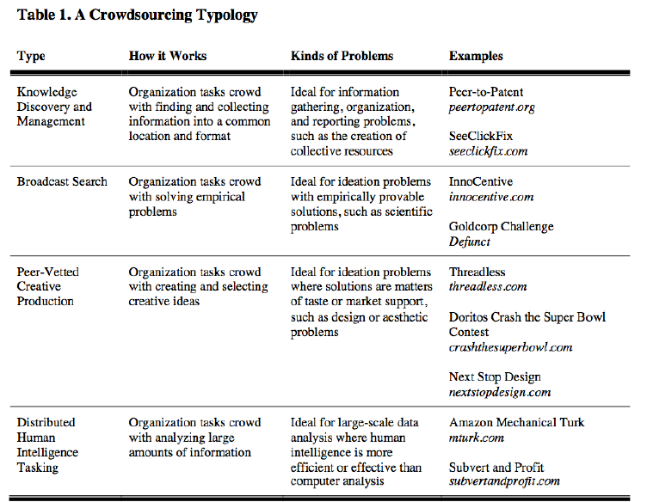

1. User innovation
2. Free and open source software
3. Accelerators, investment, etc

**Week 8 User innovation and Free and Open Source Software**

1. **Producer innovation**

* Different modes of innovation: Who is doing the innovation?

Producer innovation VS user innovation VS open collaborative innovation

* “Producer innovation”:
* Producer makes product/service for consumers
* Designs for innovations come from producer companies
* Producer innovators profit from many users of the same product/service
* Assumption that a producer serving many customers can afford to invest more in innovation than a single user innovating for themselves
* To encourage this investment, typical innovation policy allows producer to “protect” innovation through patents

1. **User innovation**
2. Lead Users

* In some product categories (eg cleaning products), market research focuses on typical users (eg with interviews, focus groups)
* The feedback and opinions of typical users can be useful in developing new products.
* For IT and other high tech industries, typical users are not so effective

Eg they often suffer from “functional fixedness”

* Involving lead users often leads to more effective innovation
* Involving lead users often leads to more effective innovation
* Lead users may be individuals, companies or communities

1. How to identify lead users

* Face the needs that will be general in the market, but months or years before the general marketplace realises the needs.
* Will benefit significantly by obtaining a solution to those needs, and…
* Spend resources trying to solve those needs
* Are at the leading edge of trends and so are very knowledgeable about “state of the art”
* Note: Lead users are not usually a company’s “lead customers” – they are usually not satisfied with current products so have had to create their own

1. Users as source of innovation

* “Lead users” can provide concepts for products, services, processes and features to help companies innovate
* Sometimes, lead users actually do the innovation themselves (i.e. “user innovation”)

Eg. WWW, Firefox add-on, Apache Server

1. **Open collaborative innovation (especially free and open source software)**
2. Proprietary software VS Free and open source software

* Traditionally most software was proprietary
* Proprietary software is software built by or for a specific person, organization or group of organizations where:

- The owner holds intellectual property rights over the software; and

- The owner has total control over the software and how it is used

* In free and open source software:

- Source code is made available

- Source code can be changed and redistributed by others

Eg. Proprietary software: Office Windows

Free and open source software: Android, Chrome

1. Definition of free software

Free software is a matter of the users' freedom to run, copy, distribute, study, change and improve the software. More precisely, it means that the program's users have the four essential freedoms:

* The freedom to run the program, for any purpose (freedom 0).
* The freedom to study how the program works, and change it to make it do what you wish (freedom 1). Access to the source code is a precondition for this.
* The freedom to redistribute copies so you can help your neighbor (freedom 2).
* The freedom to distribute copies of your modified versions to others (freedom 3). By doing this you can give the whole community a chance to benefit from your changes. Access to the source code is a precondition for this.

*Stallman’s Argument

* Computer software is becoming more and more critical for the running of a free society
* If that software is controlled by companies or governments, the software can be used to restrict or monitor people
* So, it is necessary that source code be available for all software
* If source code were not freely available, a limited number of very powerful people would dominate computing

1. Open Source Software Definition
2. “Copyleft”

“Copyleft is a general method for making a program (or other work) free, and requiring all modified and extended versions of the program to be free as well.” (Free Software Foundation)

1. To be classified as OSS, the software must be (according to its license):

* Freely redistributable
* Source code must be available for free or at reasonable reproduction cost
* Modifications and derived works must be allowed and be distributable under same

terms

* Can protect integrity of author’s source code as long as allow source code patches
* No discrimination against people/groups
* No discrimination against fields of endeavour
* Must not be restricted to use with a specific product
* Must not place restrictions on other software distributed with it
* Must be technology-neutral

1. Difference between Free Software and Open Source Software

* According to Stallman, "Open source is a development methodology; free software is a social movement.”
* Open Source covers a wider range of license types
* More ability to mix Open Source software with proprietary software than is the case for free software
* The Open Source concept was developed to bring major software businesses and other high-tech industries into the mix.
* When avoiding distinguishing between these, people use the terms:

- FOSS (Free and Open Source Software);

E.g. OSS and copyleft (changes to the source must be made available to others): The Linux kernel

OSS and not copyleft (changes to the source do not need to be made available to others): Chromium (the core of Google Chrome web browser)

1. Open source hosting sites

* Offer hosting, version control, issue tracking, wikis, download support etc
* Some support code reviews etc (E.g. Github)

1. Importance of FOSS for innovation

For enterprise IT:

* Many companies use open source software such as for:

> Internal IT infrastructure (eg Linux)

> Building and running web services (eg Apache, Apache Tomcat, JBoss)

> Building software for redistribution

* Open source software allows companies to rapidly innovate their infrastructure and services

For IT start-ups:

* Most infrastructure used in R&D and startups uses FOSS:

> Operating systems (eg Linux)

> Containers (eg Docker)

> System configuration management (eg Puppet, Chef)

* Most new software is built using FOSS:

> Software platforms (eg Java, Python, Ruby on Rails)

> Software libraries/frameworks (eg Spring framework, glibc)

> Software build and test automation (eg Jenkins, Cucumber)

* Most new software contains FOSS:

> To reduce time and cost of development

> To reduce testing and maintenance costs (assuming using stable FOSS)

> To provide compatibility with other software

> To focus on the core differentiator of your own software

1. FOSS license

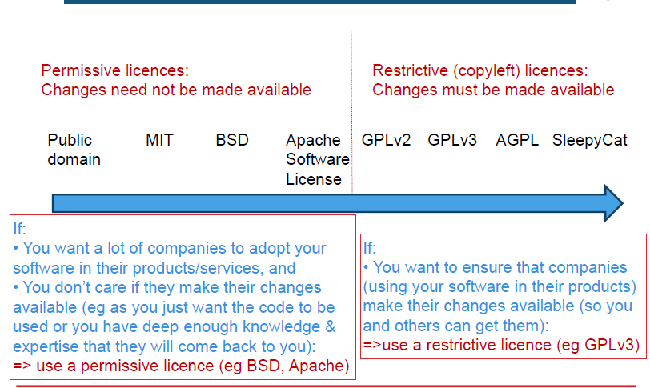

* Or use “Dual-licensing” – this is now very common
* Software can be licensed as GPL or proprietary license
* If a company doesn’t want to make their changes available, they can come to you to negotiate a proprietary license

1. Some open source business models

* Sell support and services

Example: Canonical (with Ubuntu)

* Sell certified version (with support and services)

Example: Cloudera (with Hadoop)

* Sell “enterprise edition” (effectively proprietary software)

Example: MySQL “standard edition” (not “community edition”)

* Dual licensing (copyleft so need commercial licence if modify source)

Example: Digia (with Qt)

* Cloud service using mostly open source

Examples: Facebook, Twitter

* Other advantage to the company

Example: Google (with Android)

1. Challenges in using FOSS in products and services

Challenges:

* Meeting obligations of software licenses (ensuring appropriate notices, etc)
* Possibility of accidentally “contaminating code”

E.g. a programmer introduces some GPL code from the Internet into some

proprietary product code and then the product is release

* legally, the company should release the proprietary source code
* Ensuring adequate quality of final product if some it includes some open source software of unknown quality
* Avoiding security vulnerabilities in underlying code (that may already be known to hackers)

Address the challenges:

* Companies developing products (hardware or software) or services and using open source software should have an open source policy and controls to ensure good governance.
* According to a Gartner report, <50% of Global 2000 IT Companies were planning to implement an open source governance program by 2014.

**Week 9 Organizational culture, structure and management for innovation**

1. **Culture for innovation**
2. Innovation by networked individuals (and implications for organizational culture)
3. Intrinsic motivation:

“Making progress on meaningful work”

- Workers took notes during working day:

- 12,000 electronic diary entries, 238 professionals, 7 companies

- In 1/3 of entries, worker was unhappy and/or unmotivated (often frustrated)

- Found workers far more likely to have new ideas on days when they felt happy

- Found the factor that most led to engagement of workers was:

- “Making progress in meaningful work”

- More important than bonuses, raises, etc

- More likely to lead to ideas/breakthroughs

1. The smell of the place

Constraint -> Stretch

Compliance -> Self-discipline

Control -> Support

Contract -> Trust

1. keys to a creative and innovative workplace:

* Workplaces have many opportunities for people to interact in their work
* Staff work on meaningful work
* Staff have visibility of their progress
* Environment for stretch, self-discipline, support and trust

1. **Structure for innovation**
2. Overview

* A company’s size and structure impact its ability to innovate
* Some structures may foster creativity and experimentation
* Others may enhance efficiency of product development
* Some structures may enable both simultaneously
* Traditionally large companies have done most technological innovation in-house in R&D labs
* Trend towards more “open innovation”
* involving other organizations and individuals in their innovation

1. Sizes
2. Advantages of bigger companies

* Better able to obtain financing
* Better able to spread costs of R&D: As can spread over more products
* Large size may also enable:
* Greater economies of scale and learning effects
* Taking on large scale or risky projects

1. Disadvantages:

* R&D efficiency may decrease due to loss of managerial control
* Large companies can have more bureaucratic inertia
* More commitments tie companies to current technologies

Learning effects (see Week 3); external commitments

* Small firms are often more flexible and entrepreneurial:

Can change direction quickly based on changing circumstances or new observations

1. Many big companies have found ways of “feeling small”

* Break overall company into several subunits
* Can utilize different culture and controls in different units

1. Structural dimensions which influence innovation
2. Formalization: The degree to which the company uses rules and procedures to structure the behavior of employees

Standardization: The degree to which company activities are performed in a uniform manner.

Centralization: - Centralized authority: The degree to which decision-making authority is kept at top levels of the company; - Centralized activities: The degree to which activities are performed at a central location

1. Mechanistic Structures: have high formalization and standardization.

- Good for operational efficiency, reliability.

- Minimizes variation -> may stifle creativity

Organic structures have low formalization and standardization; described as “free flowing”

- May encourage creativity and experimentation

- May yield low consistency and reliability.

1. Approaches to organizing firms for innovation: Combining the best of small and large companies

* Some divisions (e.g., R&D, new product lines) may be small and organic.
* Other divisions (e.g., manufacturing, mature product lines) may be larger and more mechanistic
* Some organizations try to do both in different divisions:
* Can also alternate through different structures over time.
* Sometimes new product development can be quite independent of even the main R&D division (e.g. “skunk works”)

1. **Managing projects for innovation**
2. Background

› In innovation projects, there are many unknowns:

- Feasibility of idea may be unknown

- Product or process concept may be vague

- Target customers may be unknown

- The way to make revenue may be unknown

› Some companies attempt to use traditional project management approaches for innovation projects

- This often fails

1. * Introducing new products to a market: Traditional model

New Product Introduction model:

Works where customers are known, product features can be specified in advance, market well-defined, basis of competition understood

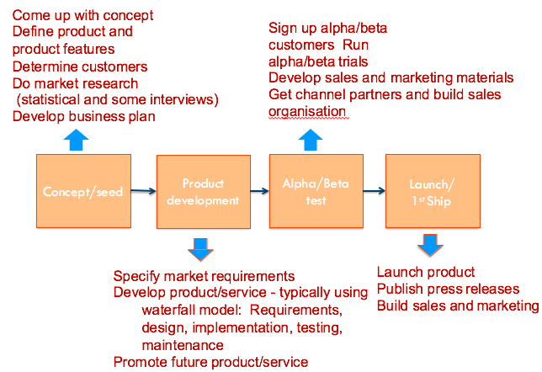

1. Problem with traditional approaches

Impossible to know all requirements in advance

* The project takes time so the requirements at the time of capture may be different from those at the time of delivery
* Some requirements are only clear when users are using the product
* Too long to get customer validation of product

1. “The Agile Manifesto” (2001)

Individuals and interactions over processes and tools

Working software over comprehensive documentation

Customer collaboration over contract negotiation

Respond to change over follow a plan

**Week12 Innovation by start-up companies**

1. **Start-ups causing creative destruction across markets**
2. **The importance of the entrepreneur**

* it is leadership rather than ownership that matters

- May be in small or large companies

- Is not necessarily an entrepreneur all the time: May be a manager in a large company carrying out day-to-day management activities

- May or may not be person who provides funding: Not necessarily the “risk-taker” (in economic sense)

1. **\*Traditional approach: Treat start-up as small version of large company**

- Founders used techniques learned in business schools as used by big companies

- Most businesses needed a business plan to start

- Business plan needed for investment (bank, venture capital, etc)

- Business plan focused on:

* Identifying business opportunity (addressable market)
* Problem to be solved
* Planned solution to problem
* Forecast for income, profit, costs etc (eg for 5 years)
* Frequently unsuccessful for tech start-ups as:
* For tech startups, there are many uncertainties
* The plan may have many untested assumptions
* Much of the plan may rely on these untested assumptions
* The business plan is often rigid and hard to change direction quickly

1. **Definitions of startups**

* a temporary organization in search of a scalable, repeatable, profitable business model
* a human institution designed to deliver a new product or service under conditions of extreme uncertainty

1. **Established companies vs startups**

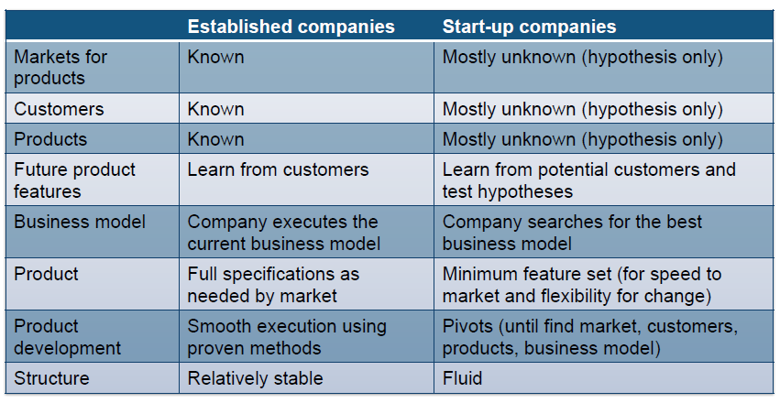

1. **Why traditional product processes are not suitable for startups**

Traditional new product introduction processes are not suitable for situations of uncertainty (eg most startups) as not enough is known about customers, needed features, etc

- The 9 deadly sins of the New Product Introduction Model:

1) Assuming “I know what the customer wants”

2) The “I know what features to build” flaw

3) Focus on Launch date

4) Emphasis on execution instead of hypotheses, testing, learning and iteration

5) Traditional business plans assume no trial and no errors

6) Confusing traditional job titles with what a startup needs to accomplish

7) Sales and marketing execute to a plan

8) Presumption of success leads to premature scaling

9) Management by crisis leads to a death spiral

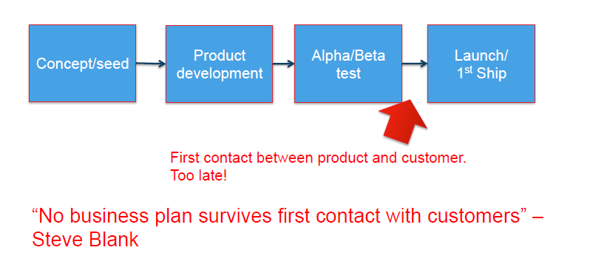

1. **New approaches for startups:**
2. Customer Development Process:

The Customer Development process has been designed to help scalable startups find a scalable business model

* Works where customers are unknown, product features unknown, market unknown, basis of competition unknown – i.e. Designed to solve “the 9 deadly sins”

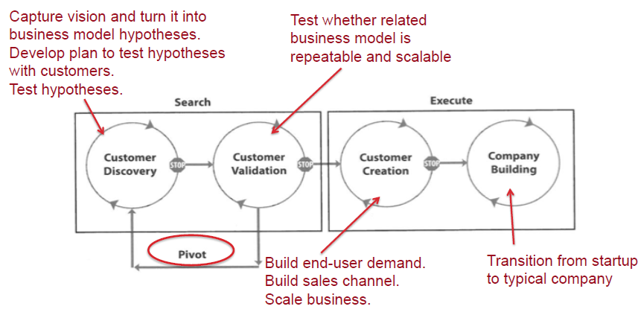

* The Customer Development Manifesto

› Rule 1. There are no facts inside your building, so get outside

› Rule 2. Pair Customer Development with Agile Development

› Rule 3. Failure is an integral part of the search

› Rule 4, Make continuous iterations and pivots

› Rule 5. No business plan survives first contact with customers so use a business model canvas (more soon)

› Rule 6. Design experiments and test to validate your hypotheses

› Rule 7. Agree on market type. It changes everything

• Bringing a new product into an existing market

• Bringing a new product into a new market

• Bringing a new product into an existing market and trying to:

• Re-segment that market as a low-cost entrant

• Re-segment that market as a niche entrant

• Cloning a business model that’s successful in another country

› Rule 8. Startup metrics differ from those in existing companies (more later)

› Rule 9. Fast decision-making, cycle time, speed and tempo

› Rule 10. It’s all about passion

› Rule 11. Startup job titles are very different from a large company

› Rule 12. Preserve all cash until needed. Then spend

› Rule 13. Communicate and share learning

› Rule 14. Customer development success begins with buy-in

1. The Lean Startup

The Lean Startup approach provides a useful model for IT startups which combines

Customer Development and Agile Development

* Not every startup can be done lean, Big visions for short-term monopoly
* Focus on big vision rather than incremental niche-making by pivoting
* Focus on monopoly for a time in a market (e.g. Google) rather than continual competition

1. The Business Model Canvas

* Startup = the search for a business model
* Business model canvas = a representation of a business model
* A startup is the processing of filling in a business model canvas
* The Business Model Canvas:

- Good for representing

•what’s known (results of hypothesis testing)

•what hypotheses still need to be tested

Key Partners Channels

Key Activities Customer Segments

Key Resources Cost Structure

Value Propositions Revenue Streams

Customer Relationships

* – Software available (eg iPad version)
* – Online services available:

1. Value Proposition Canvas

The Business Model Canvas and Value Proposition Canvas provide useful templates to help guide development of business models

还有ecosystem的题，写两个ecosystem中重要的factors，government扮演了什么样的角色。

倒数第二题

有人说：“有一种市场，客户很少，但每个客户需要大量产品；另一种市场，客户很多，但每个客户只要很少量产品。前一种市场更容易”用课上的观念解释

Week3 chasm

从early adopt 到early majority需要大量努力

最后一题

Twitter五年以后消失了，有哪些可能原因，课上学过的观念解释

1.其它disruptive innovation取代了它

2.现在对它的期待处于最高点，过几年反而下降了。Week3 hyper-cycle